**DAILY ONLINE ACTIVITIES SUMMARY**

|  |  |  |  |  |  |  |  |  |
| --- | --- | --- | --- | --- | --- | --- | --- | --- |
| **Date:** | **04/06/2020** | | | | | **Name:** | **RITIKA KULKARNI** | |
| **Sem& Sec** | **4thSEM. & ‘B’ SEC.** | | | | | **USN:** | **4AL19CS403** | |
| **Online Test Summary** | | | | | | | | |
| **Subject** | | **MICRO-CONTROLLER AND EMBEDDED SYSTEMS** | | | | | | |
| **Max. Marks** | | **30** | | **Score** | | | **18** | |
| **Certification Course Summary** | | | | | | | | |
| **Course** | **Python for Machine Learning** | | | | | | | |
| **Certificate Provider** | | | **Greatlearning**  **Academy** | | **Duration** | | | **5 Hrs.** |
| **Coding Challenges** | | | | | | | | |
| **Problem Statement:**  **Given an array C of size N-1 and given that there are numbers from 1 to N with one element missing, the missing number is to be found.**  **Input:**  **The first line of input contains an integer T denoting the number of test cases. For each test case first line contains N(size of array). The subsequent line contains N-1 array elements.**  **Output:**  **Print the missing number in array.** | | | | | | | | |
| **Status:** | | | | | | | | |
| **Uploaded the report in Github** | | | | | **Yes** | | | |
| **If yes Repository name** | | | | | <https://github.com/ritikakulkarni/QuarantineCoding-C_Coding/blob/master/MissingNumber.c> | | | |
| **Uploaded the report in slack** | | | | | **Yes** | | | |

**Online Test Summary: 18CS44 test was scheduled from 9:15 am to 9:50 am.The portion for the IA was 4 th module there were 25 questions and the time assigned was 40 minutes the questions were mcq type. But there was an issue with the time mentioned, so that we got only 30mins. to finish the test. The time was not sufficient to answer all the questions. There were 20 questions of 1 marks and 5 questions of 2 marks respectively.**

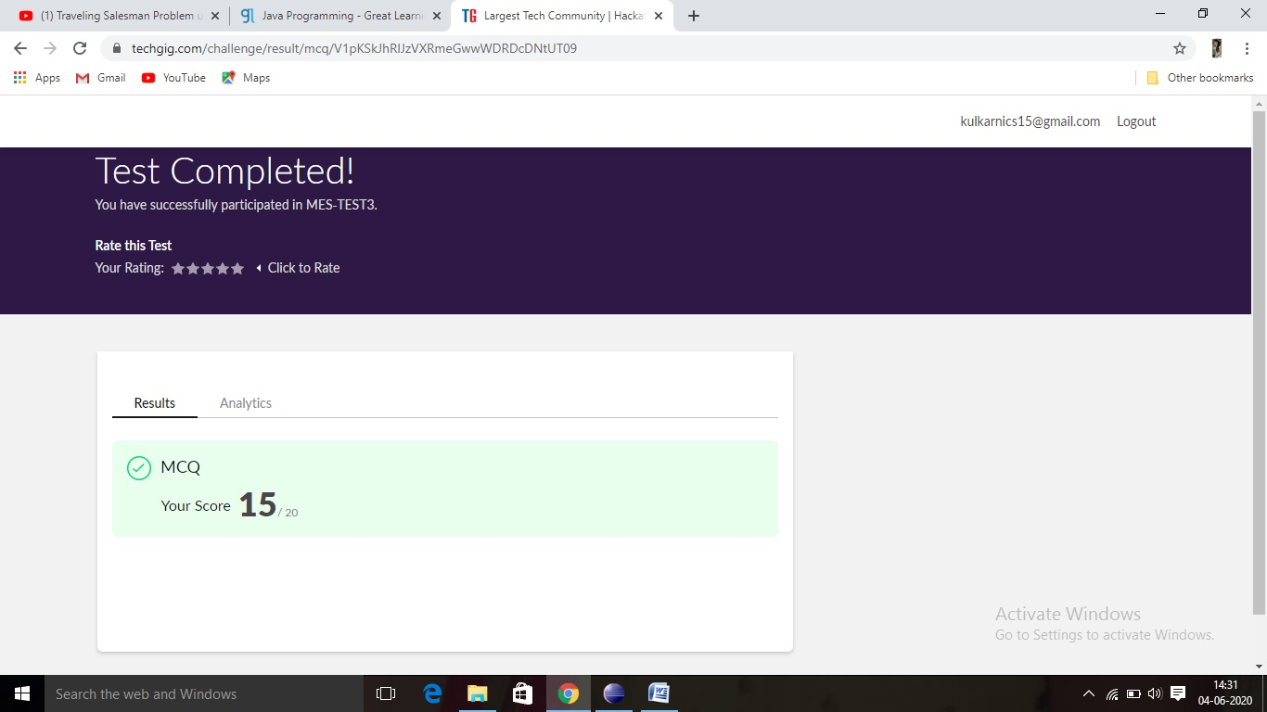

**Certification Course Summary: Today I have learnt about the jupyter notebooks ,how to create a new note book and how to execute the code in the cell provided in the notebook and about some of the keyboard shortcuts which helps to execute the code and to achieve the output and some of the basic data structure hands-on.**

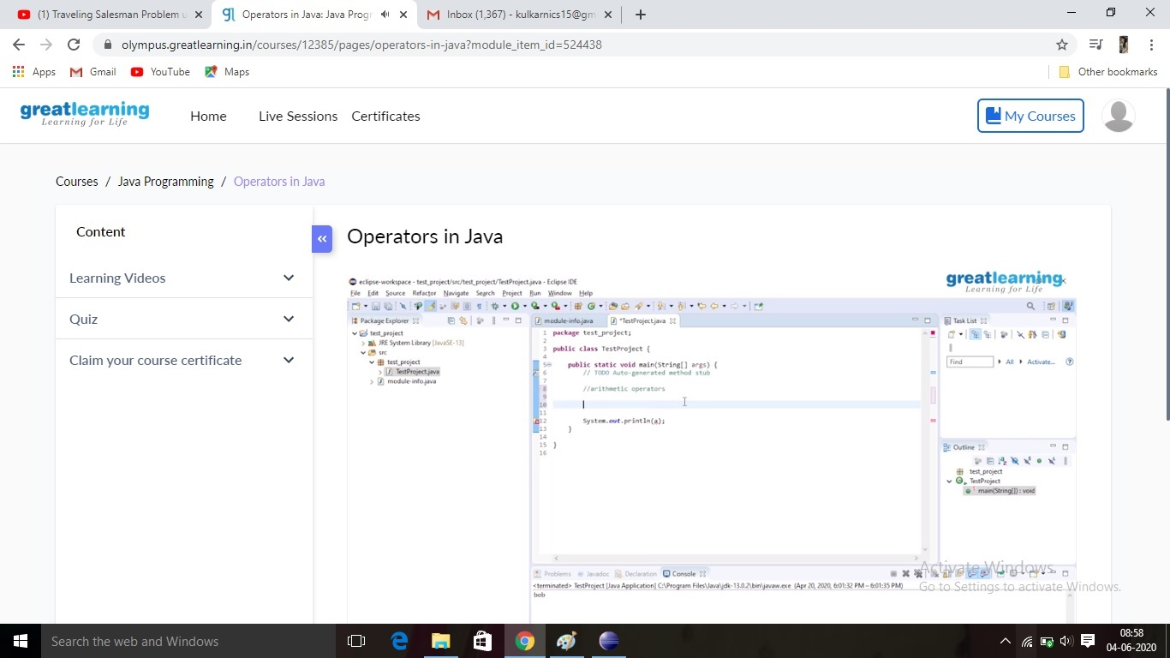

**Online Coding Summary:Online Coding Summary​: Online coding Summary: Today I received one program from Prof.Venkatesh CSE Dept. The program is mentioned above(pg.01). to my GitHub repository and I’ve shared the snapshot below.**

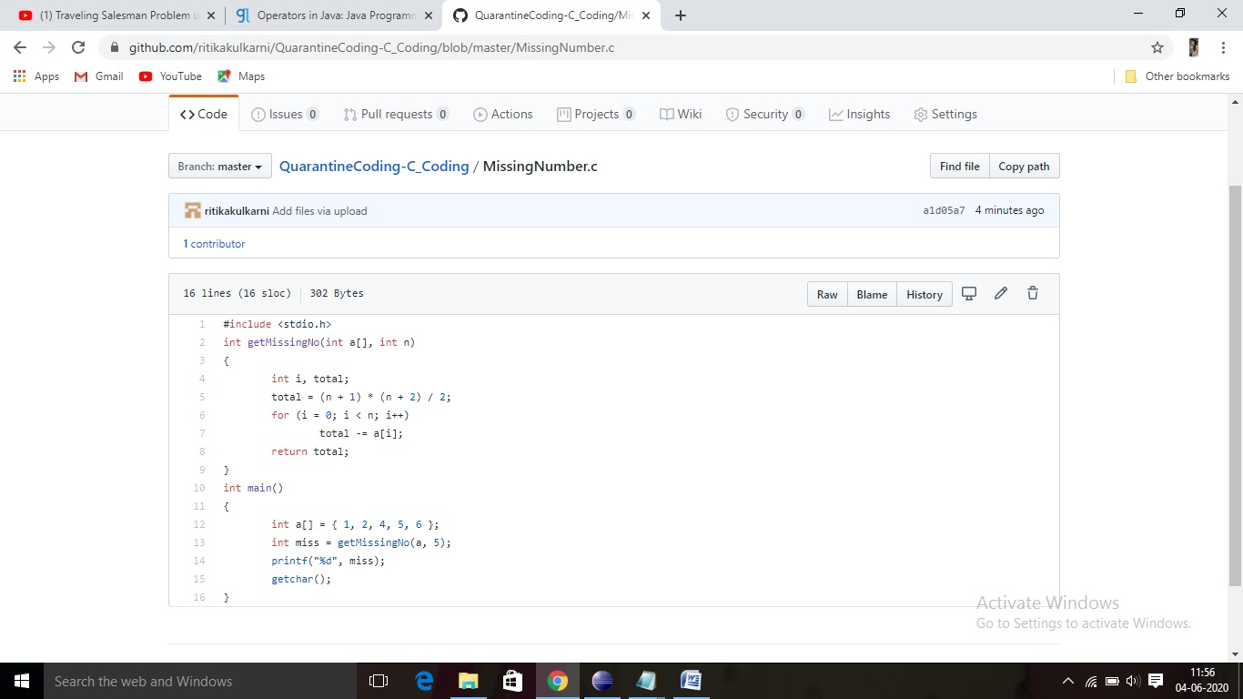

**Thank you.**